Formal Lab Report Unknown “A”
Taylor Godwin
November 28, 2013
Chem 2081-001
Introduction
For today’s lab experiment, the goal is to identify an unknown compounds chemical formula and present its structure through use of three different techniques that reveal different types of information about a compound. The three techniques are Gas Chromatography-Mass Spectrometry, Nuclear Magnetic Resonance, and Fourier-Transform Infrared Spectroscopy. Each technique uses different chemical and physical properties of the molecules themselves, and the atoms that make up these molecules to reveal small pieces of insight into the makeup or structure of the compounds in question. The proficient use of these techniques is a necessary skill to master because it allows one to take a chemical which is completely unknown and learn all about it. This is useful for identification of novel compounds, conformation of an expected product, or for research purposes in general. It is immensely applicable because often times in a professional or research setting, a compound or substance must be either confirmed or identified, and the knowledge of how to use these three variations of spectroscopy will allow almost every chemical property to be known once utilized.

Theory
NMR
Nuclear Magnetic Resonance (NMR) spectroscopy is a powerful analytical technique deployed in the determination of the molecular structure and dynamics of organic and inorganic compounds. It is extensively utilized in the field of chemistry, biochemistry, and materials science, amongst others. NMR is predicated on the interplay between atomic nuclei and a potent magnetic field, as well as electromagnetic radiation, rendering it efficacious in detecting and quantifying the chemical environment of nuclei.
NMR spectroscopy involves gauging the energy absorbed or emitted by atomic nuclei when confronted with a magnetic field and electromagnetic radiation. In the presence of a magnetic field, atomic nuclei undergo Zeeman splitting of their energy levels. Upon exposure to radiofrequency radiation, the nuclei can transition between the energy levels by absorbing or emitting energy. The chemical environment of the nuclei, such as the local magnetic field strength, the proximity of adjacent atoms, and the electron density around the nuclei, determine the magnitude of energy absorbed or emitted. This information is subsequently leveraged to ascertain the structure and composition of molecules.
The NMR instrument incorporates a potent magnet, a radiofrequency transmitter, and a detector. The sample under investigation is placed in the magnet, and the magnet establishes a robust magnetic field that aligns the atomic nuclei in the sample. The radiofrequency transmitter then sends a pulse of radiation to the sample, causing the nuclei to absorb energy and transition between energy levels. The detector records the energy absorbed or emitted by the nuclei, and this information is utilized to produce an NMR spectrum.
NMR spectra provide a plethora of information regarding the number and types of atomic nuclei in a molecule, their chemical environment, and their relative positions in the molecule. The most common nuclei analyzed in NMR spectroscopy are hydrogen-1 (1H) and carbon-13 (13C), which are the most prevalent isotopes of hydrogen and carbon, respectively. Other isotopes, such as nitrogen-15 (15N), oxygen-17 (17O), and fluorine-19 (19F), can be analyzed by NMR spectroscopy as well.
In a 1H NMR spectrum, the peaks represent the different types of hydrogen atoms in the molecule. The chemical shift, measured in parts per million (ppm), indicates the chemical environment of the hydrogen atoms. Chemical shifts are affected by the electron density around the hydrogen atoms, the magnetic shielding effect of neighboring atoms, and the hybridization state of the carbon atoms bonded to the hydrogen atoms. The number of peaks corresponds to the number of different types of hydrogen atoms in the molecule. The peak intensity indicates the number of hydrogen atoms of each type in the molecule.
NMR spectroscopy can also provide information on molecular structure and dynamics. The coupling between neighboring atomic nuclei, known as spin-spin coupling, can reveal the distance and relative orientation of atoms in a molecule. The relaxation times of the nuclei can provide information on molecular motion and dynamics.
FTIR
FTIR, or Fourier Transform Infrared Spectroscopy, is a highly valuable analytical technique that is widely used to detect and quantify chemical compounds in various types of samples. The technique is based on the interaction of infrared radiation with the chemical bonds present in the sample, resulting in the absorption of specific frequencies of light that are characteristic of the compound. The resulting spectrum is then analyzed to identify functional groups, molecular structure, composition, and concentration of the sample.
To use FTIR, the analyst must first prepare the sample for analysis, which may involve grinding, mixing, or dissolving the sample in a suitable solvent. The sample is then placed in a sample holder, which is inserted into the FTIR instrument for analysis. Before analysis, the instrument must be calibrated using a suitable reference sample to ensure accurate measurements.
Data acquisition is performed by irradiating the sample with infrared radiation over a range of frequencies and detecting the amount of radiation absorbed by the sample at each frequency. The resulting spectrum is then processed using Fourier transform algorithms to produce a frequency-domain spectrum. This spectrum is represented as a plot of absorbance versus wavenumber, with peaks at specific wavenumbers corresponding to the types of bonds present in the sample.
The next step is to analyze the resulting spectrum to identify the types of bonds present in the sample. This can be done by comparing the positions of the peaks in the spectrum to those in a reference database. A peak at a specific wavenumber corresponds to a specific bond or functional group, such as an OH group or a C=O bond. By comparing the spectrum to a database of known spectra, the analyst can identify the types of bonds present in the sample.
In addition to identifying the types of bonds present, the FTIR spectrum can also be used to quantify the concentration of each bond or functional group. This is done by measuring the peak height or area and comparing it to a calibration curve generated using known standards. The resulting quantitative data can be used for quality control, process optimization, or research purposes.
MS
Mass spectrometry (MS) is an analytical technique with many applications in various fields, including chemistry, biology, and environmental science. It is used to determine the molecular weight and structural information of a sample by ionizing the sample to create ions. These ions are then separated based on their mass-to-charge ratio (m/z) and detected using a mass spectrometer. The resulting mass spectrum provides information on the number and relative abundance of ions in the sample, which can be used to infer the chemical composition of the sample.
After ionization, the ions are separated based on their m/z using a mass analyzer. Several types of mass analyzers can be used in MS, each with its unique characteristics. Quadrupole analyzers, for example, use an electric field to separated the ions based on their m/z, while time-of-flight (TOF) analyzers use the difference in flight time of the ions to separate them. Other types of analyzers include magnetic sector analyzers and ion trap analyzers, each with its strengths and limitations. The ions are then detected, and the resulting mass spectrum provides information about the sample. MS data can provide information on molecular weight, structural information, and the presence of impurities or contaminants in the sample. For example, MS can be used to identify the components of a complex mixture, such as a protein sample or a petroleum sample.
By analyzing the mass spectrum, researchers can determine the m/z of the different components in the mixture and identify the individual components based on their known molecular weight. In addition to identifying individual components, MS can also provide information about the fragmentation pattern of a molecule. This information can be used to infer its chemical structure and to identify specific functional groups present in the molecule. For example, MS can be used to identify the presence of a particular amino acid in a peptide sequence or the presence of a specific metabolite in a biological sample. To interpret mass spectrometry data, it is important to understand the different features of the mass spectrum. The x-axis of a mass spectrum represents the mass-to-charge ratio (m/z) of the ions, while the y-axis represents the relative abundance of the ions. The peaks in the spectrum correspond to different ions present in the sample, with the highest peak corresponding to the ion with the highest relative abundance. The m/z value of each peak can be used to determine the mass of the ion. However, it is important to note that not all peaks in a mass spectrum correspond to ions that are part of the sample. Some peaks may be due to impurities or contaminants in the sample or may be caused by fragmentation of the sample during ionization. In conclusion, MS is a powerful tool used to identify molecular weights and can provide great insight into unknown chemical structures.

Data Set A

NMR
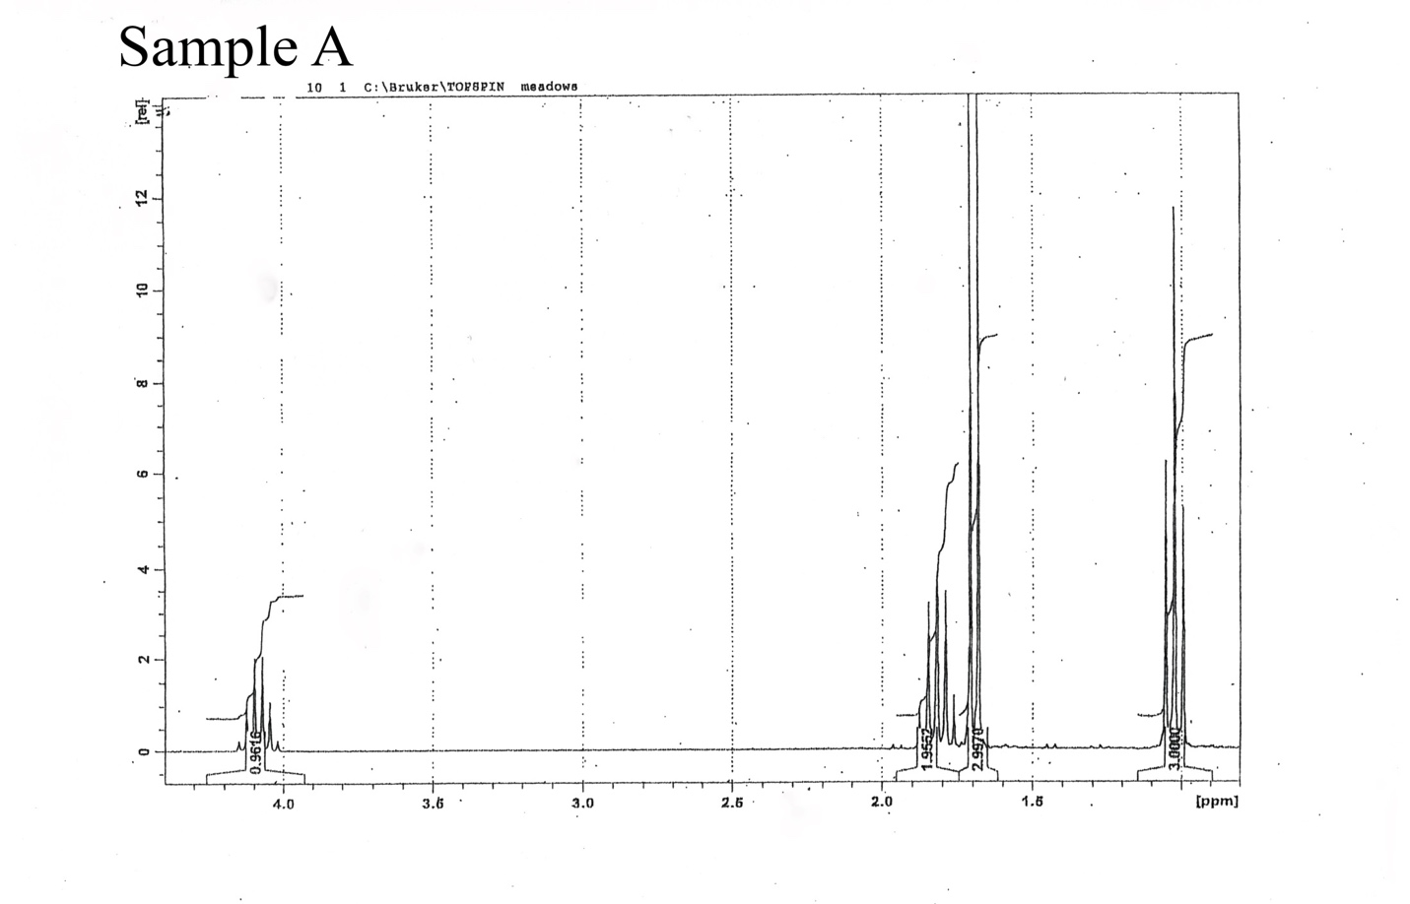

FTIR
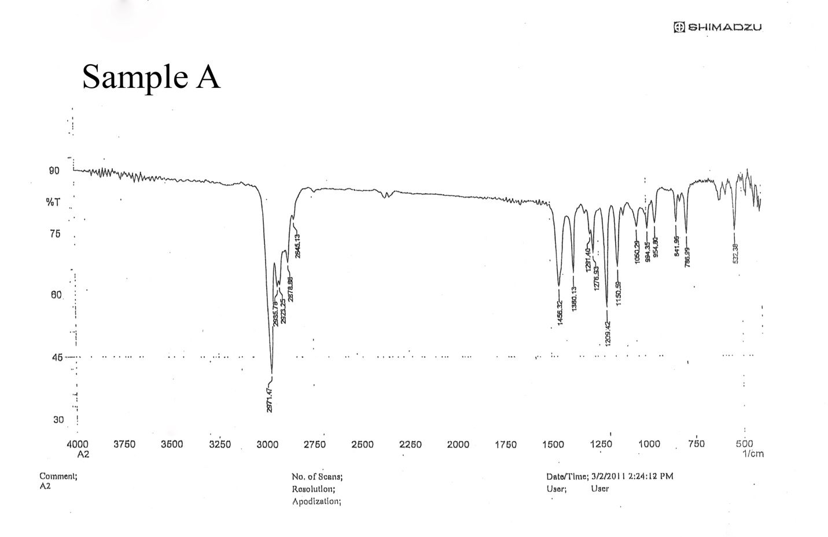

MS
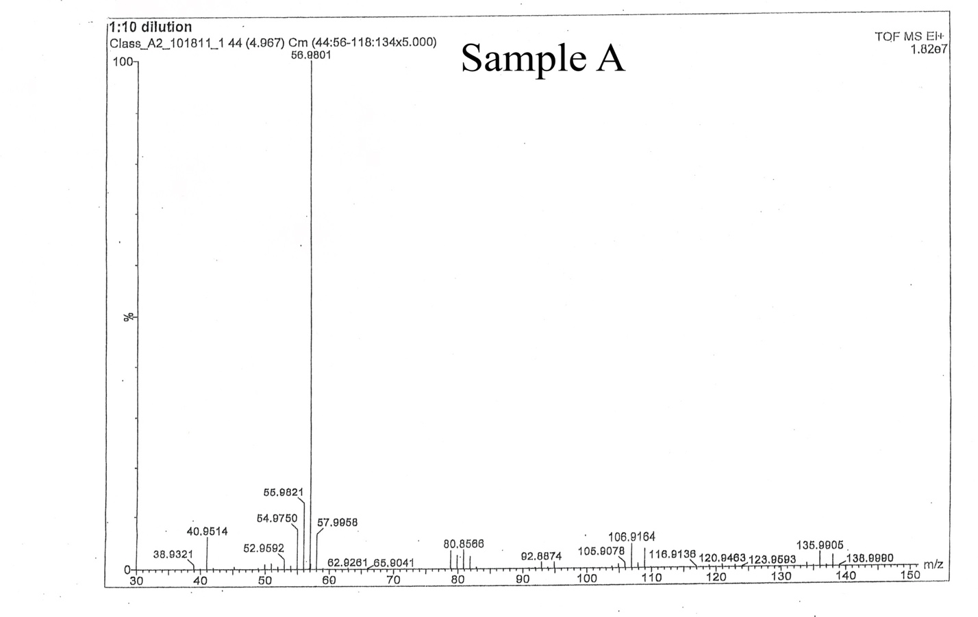

Analysis
NMR
The NMR Spectrum reveals four different peaks indicating four different groupings of protons. One proton grouping is shifted to 4.1 which indicates that it is adjacent to something that is electronegative. This grouping also has a multiplicity of 6 so it indicates there is 5 adjacent hydrogens. The highest grouping has an integration of 1, then the next highest grouping has an integration of 2, then the smallest two groupings have an integration of 3.
FTIR
The FTIR Spectrum reveals that there is a large peak in the 3600-2850 cm⁻¹ range which indicates that there are only C-H alkane bonds present. There are no bonds present in the 2300-2100 or 1850-1620 ranges which indicates that there are no alkynes, alkenes, carbonyl, or nitrile functional groups present. The peak in the spectrum is present at 3000 cm⁻¹ and is a very narrow peak which that the structure is an alkane. The lack of a broad peak rules out the presence of an alcohol group. The lack of peaks above 3000 cm⁻¹ rules out the presence of nitrogen groups and alcohol groups as well.
MS
The Mass Spectrum indicates the M⁺² peak at 135.99 m/z and the base peak at 56.98 m/z. There are two strong peaks at 135.99 m/z and 138.99 m/z which indicates the presence of a Bromine in the structure. Since the strong peaks are two apart this indicates that the isotopes of Bromine are at a 1:1 ratio. The base peak located at 56.98 m/z indicates that a butyl group is present. The subtraction of the base peak from the M⁺² peak (135.99 m/z -56.98 m.z =79.07 m/z) indicates that a Bromine is present since it is 79 m/z.
Conclusion
First, the strong peaks at 135.99 m/z and 138.99 m/z indicates that a Bromine is present. A Bromine is confirmed by the subtraction of the base peak from the M⁺² peak (135.99 m/z -56.98 m.z =79.07 m/z), which gives us 79.07 m/z indicating a Bromine. The FTIR spectrum confirms the structure is an alkane and all carbons are sp³ hybridized since the only peak is in the 3600-2850 region. The NMR spectrum confirms the alkane structure and since there are only four groupings then we can logically conclude that the structure is a butyl group. On the NMR, the highest grouping has a multiplicity of 6 which means that it is adjacent to 5 hydrogens. The only way that this is possible is for the Bromine to be located on an inner carbon in the butyl structure. The shift of the highest peak, with a multiplicity of 6 (indicating a CH₃ group), to 4.1 also confirms that the grouping is adjacent to something electronegative, which is the Bromine on the inner carbon. From this information, we can know that the structure of the unknown sample is 2-bromobutane. The structure is provided below.
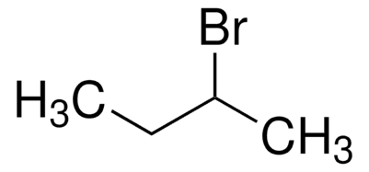
References
Keller L, Joseph K, and Miguel S. 2022 Fall. CHEM 2081 Organic Chemistry 2 Lab Manual [lab manual]. Auburn (Al): Auburn University.
Klein, D. R. (2021). Organic Chemistry. Wiley.

